Structured Decision Making in Conservation Program of Mahakam Irrawaddy Dolphin (*Orcaella brevirostris* Gray, 1866)

By Trifan Budi (62110700101)

**Introduction**

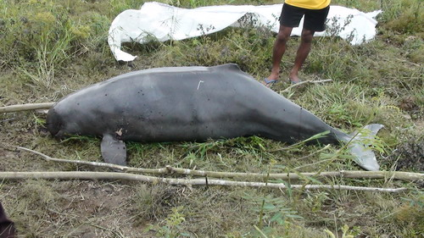

Figure 1. Stranded Irrawaddy dolphin (RASI, 2018)

Irrawaddy dolphin is a unique species known as facultative river dolphin due to its ability to inhabit freshwater to coastal ecosystem. This species distribution is from the Bay of Bengal stretching to Southeast Asia. This species experiencing declining population trend and assigned by IUCN Redlist as Endangered, even assigned as Critically Endangered in some of its subpopulation(Kreb, Smith, & Beasley, 2004; Minton et al., 2018). Irrawaddy dolphin inhabiting Mahakam river in Indonesia is one of the subpopulations that assigned as Critically Endangered. This subpopulation is small and isolated in the upper part of the Mahakam river with the abundance estimation of 81 Individual in 2019 (RASI, 2019). Mahakam Irrawaddy dolphin assumed as a total freshwater resident based on ~20 years observation. This population estimated have 5.7% annual death rate. This population is subject to anthropogenic pressure threats like unsustainable fisheries, habitat loss and degradation, high intensity of river transportation, as well as river pollution (Minton et al., 2018).

Figure 2. Population trend of Mahakam Irrawaddy dolphin (RASI, 2018)



Figure 3. Mahakam Irrawaddy Dolphin distribution in Mahakam River (Adapted from (Kreb & Budiono, 2005).

Mahakam Irrawaddy dolphin mainly distribute in the middle of the river (Figure 3). Between its distribution and coastal are separated by the city of Tenggarong and Samarinda which have high human activities along the river. This distribution made it impossible to crossing into its coastal relatives since this species have high fidelity and have maximum daily range is below 40 KM while the distance to the coastal area is 160 KM. Moreover, this dolphin tend to avoid location with high human activities (Kreb & Budiono, 2005; Kreb & Rahadi, 2005; Noor, 2013).

Given the explanations, conservation of Mahakam Irrawaddy dolphin should be priority and structured decision making can be used to achieve the objectives.

**SDM framework for Mahakam Irrawaddy dolphin conservation**

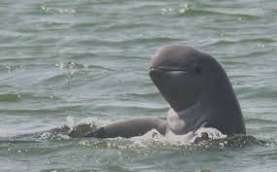

Alternative Action

Define Objectives

1. Minimizing annual death
2. Habitat protection and restoration

Habitat loss and pollution

Prey depletion

High annual death rate

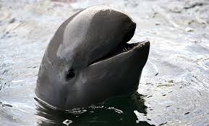

Predict the system respond in short and long-term

(See below)

Optimization and define trade-offs

(See below)

Adaptive Management

Decide and take-actions

(See below)

**Problems**

Mahakam Irrawaddy dolphin have declining trend in its abundance due to its high mortality rate associated with gillnet entanglement, unsustainable fisheries practices which lead to depleted of its prey, river pollution associated with habitat loss and conversion into palm oil plantation and mining, and collision with boats. These made mortality rate of this population are higher than overall population threshold (overall threshold of 5%) (Minton et al., 2018). Minimizing death rate became critical due to this population is rule out by death and birth. The immigration or emigration did not take account for this population due to it disperse around 160 KM to its coastal relative while its maximum daily range is below 40 KM (Noor, 2013) and there are high human activities in the lower part of the Mahakam which prevent them to move to the coastal area. Apart from minimizing the death rate of the population, we can do habitat protection and restoration in order to provide better habitat for this dolphin and its prey.

**Objective (s)**

Given the explanation, decreasing Mahakam Irrawaddy dolphin annual death rate will be the first objective on its conservation decision. Another objective in its conservation decision is to minimize habitat conversion and maximize habitat restoration around the river to provide habitat for its prey.

**Alternative action**

Some actions that can be done in order to achieve the objectives are (adapted from (Kreb & Budiono, 2005):

1. Promoting sustainable fisheries
2. Local awareness
3. Protected area enforcement
4. Limiting river transportation
5. Dolphin Rescue Training
6. Installing Pinger equipment in the dangerous location

**Consequences Table**

|  |  |  |
| --- | --- | --- |
| Alternative | Minimizing annual death | Habitat protection and restoration |
| Promoting sustainable fisheries | **++** | **++++** |
| Local awareness | **-** | **++** |
| Protected area enforcement | **+** | **++++** |
| Limiting river transportation | **++** | **++** |
| Dolphin rescue training | **++++** | **-** |
| Installing Pinger | **++++** | **-** |

**Influence Diagram**

**`** 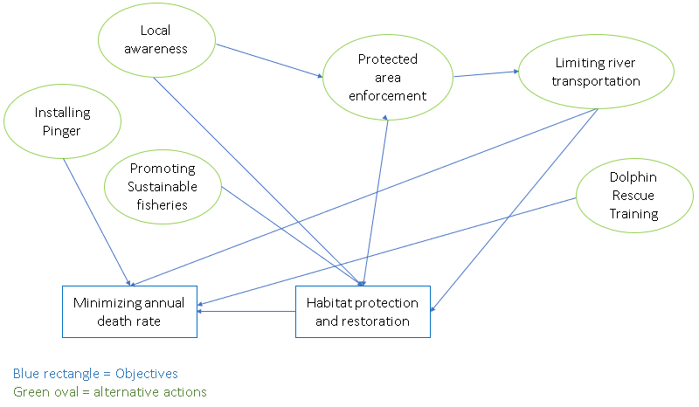

**Trade off**

Minimizing annual death rate of the Mahakam Irrawaddy dolphin will be significantly good for population abundance for long short term and cost less but habitat protection and restoration might give unsignificant effect and higher cost for short term but will ensure long-term population persistence, not only for Irrawaddy dolphin but also for the other species in Mahakam river.

**Decisions**

Promoting sustainable fishery practices along with protected area enforment indicate best management strategy for this population. Because promoting sustainable fishery practices will directly reduce the massive use of gillnet which causing majority of the dolphin death and also give positive impacts for habitats and ensure prey avaibility. Impacts of this action along with protected area enforcement will give maximal result for dolphin protection.

**References**

Kreb, D., & Budiono. (2005). Conservation management of small core areas: Key to survival of a Critically Endangered population of Irrawaddy river dolphins Orcaella brevirostris in Indonesia. *Oryx*, *39*(2), 178–188. https://doi.org/10.1017/S0030605305000426

Kreb, D., & Rahadi, K. D. (2005). Living Under an Aquatic Freeway: Effects of Boats on Irrawaddy Dolphins (<I>Orcaella brevirostris</I>) in a Coastal and Riverine Environment in Indonesia. *Aquatic Mammals*, *30*(3), 363–375. https://doi.org/10.1578/am.30.3.2004.363

Kreb, D., Smith, B. D., & Beasley, I. (2004). Facultative river dolphins : conservation and social ecology of freshwater and coastal Irrawaddy dolphins in Indonesia. *Oryx*, pp 401. Retrieved from http://dare.uva.nl

Minton, G., Smith, B. D., Braulik, G. T., Kreb, D., Sutaria, D., & Reeves, R. R. (2018). Orcaella brevirostris, Irrawaddy Dolphin. Retrieved August 5, 2019, from The IUCN Red List of Threatened Species website: http://dx.doi.org/10.2305/IUCN.UK.2016-3.RLTS.T20010A22247615.en

Noor, I. Y. (2013). *Re-Desain Konservasi Pesut Mahakam ( Orcaella Brevirostris Gray, 1866) Berbasis Perubahan Sebaran Di Sungai Mahakam, Kalimantan Timur.* Sekolah PascaSarjanaInstitut Pertanian Bogor. Retrieved from https://repository.ipb.ac.id/bitstream/handle/123456789/66805/2013iyn.pdf?sequence=1&isAllowed=y

Unpublished data by Conservation Foundation for Rare Aquatic Species of Indonesia (RASI) year 2018 and 2019.